Touhou 9 (Phantasmagoria of Flower View) Specification

Overview
The below is intended to act as a thorough implementation guideline to assist in foreplanning of a clone of the 9th main-series Touhou Project videogame, Phantasmagoria of Flower View, complete with netplay and conceptualised object-oriented systems design to achieve the desired end product with as minimally convoluted a programming endeavour as possible. This will utilise heavily the notion of OOP and various related design patterns to separate the program into many manageable components of behaviour, which, in turn, dramatically easen the process of development as each can be trivially implemented largely in a vacuum from the rest, subsequently being combined into the agglomeration that is the overall project.

Each section will demonstrate a set of solutions concerning the replication of the game’s existing behaviours and how they can be implemented effectively and efficiently. I seek to keep things largely language-agnostic, as the resulting project can be fulfilled in any language that provides comfortable access to a window and graphics system; ideal targets would be Python (ease of implementation); or Java, C++, and C# (high performance). Furthermore, this brief will also be agnostic of any libraries and pipelines necessitated for graphics and rendering purposes, so the specification can be adhered to unstintingly whilst using any kind of graphics environment: mere Pygame, or OpenGL.

For this reason, any examples will be written in (an albeit Pythonesque) pseudocode, aiding in legibility and transcription to another language.

Structure
The document will begin with a layout specifying exactly what behaviours the game should have. The latter half will complement the specified information by suggesting a comprehensive implementation scheme.

Part I: Description

1 Main Menu

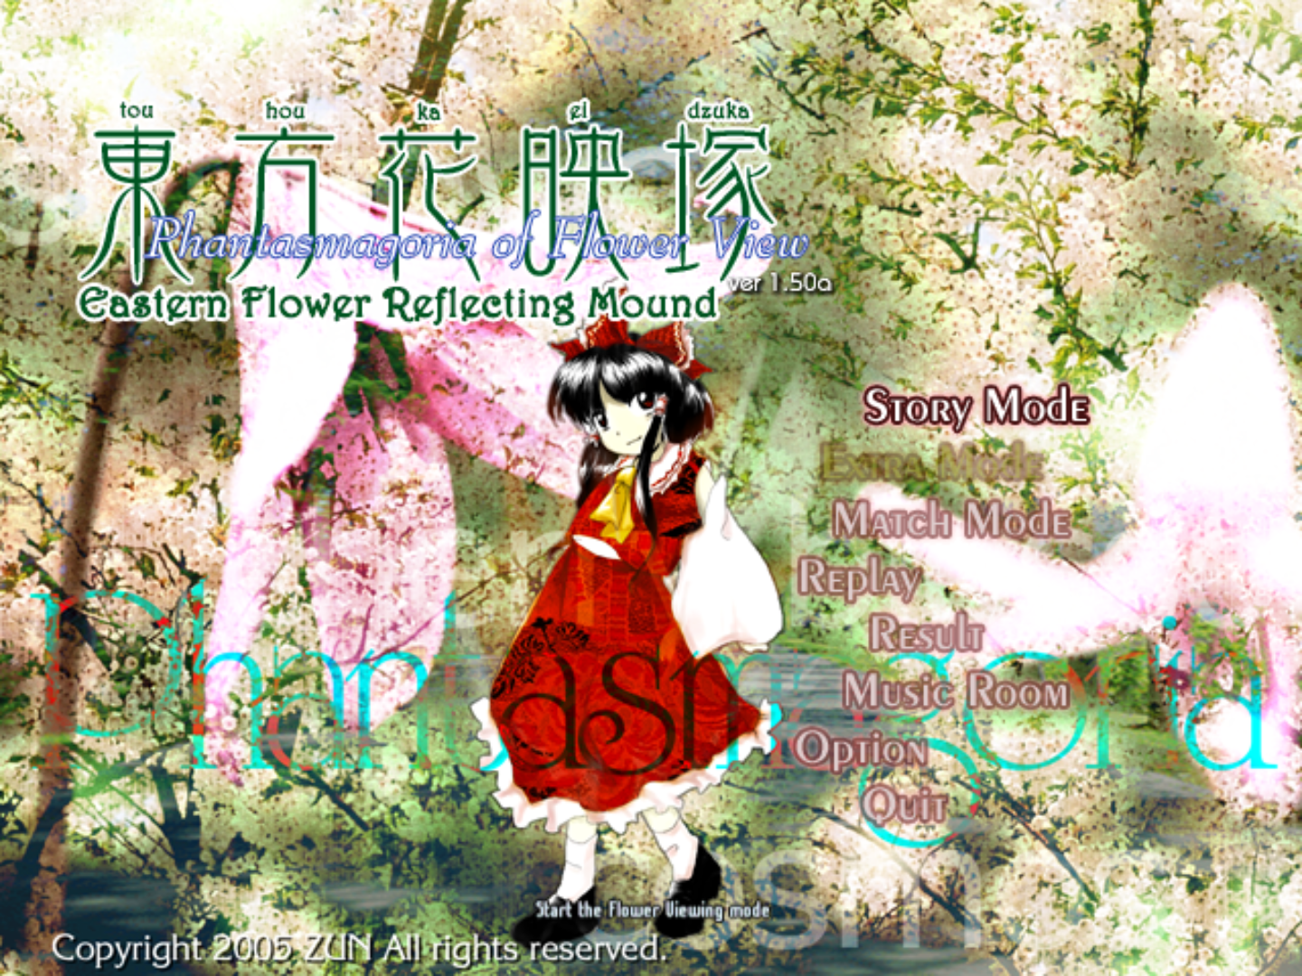
The main menu for the game. Features a static background with dynamic textual labels which drive the user’s interaction with the game before the game begins.

1.1 Behaviour of the text labels
Each text label is a span of text with a defined (x, y) position on the screen. A label, when displayed, can either be highlighted — in which case it displays in full opacity; locked — in which case it is very transparent and shaded out red; or unselected — in which case it is slightly transparent. The labels’ positions are not strictly fixed: each one periodically switches from its default position to a slightly different one on an interval of about 15 seconds. Each label also has a tooltip, which suggests to the user the purpose of the menu option. As each label represents a distinct action, often time opening a sub-menu, this means a label also has an inherent “action” property or function which stipulates what is to be done when that option is chosen.

1.2 Driving the menu
The labels alone do not constitute a menu; a menu would be a collection of labels, some unlocked, and perhaps some locked, which keeps track of the currently selected label and allows the user to select a new one using the arrow keys (up and down). The user’s choice may then be enacted by pressing Z; this will cause the menu item to perform a given action.
The menu must, therefore:
- Keep track of all the labels in a list-like structure.
- Keep track concretely of which label is currently selected.
- Decide which new label to transition to when a vertical arrow key is pressed.
- Perform an action, when the Z key is pressed, according to the respective label.

2 Gameplay (Story Mode)
This stage of the game represents the phase where the heart of the game takes place — gameplay. A variety of factors, such as the many interplaying enemies, bullets, and visual elements, must all be managed coherently to ensure quality code.

2.1 Levels
The campaign game consists of levels. There are 9 of them, increasing in difficulty. Each level stipulates its own variety of enemies to spawn (although they are largely the same all the way through). Each level should have its own music, which is played once any character dialogue is complete. Depending on the level, Player 2 should be a different boss.
Each stage also has a background — this is what decides how the stage should look visually, provided there are no overriding spell cards in progress. In campaign mode, the player begins with 3 lives, indicated by yin-yang orbs. The player gains additional lives for reaching the scores of 10, 30, 50, 70, and 90 million points.

2.1.1 Music
Music has an associated music file, a looping point in that file (which specifies where to loop the song at to make the music sound seamless), and a song name, which is displayed briefly at the beginning of each level for 3 seconds.

2.2 Players
There are two screens, with one for Player 1 and one for Player 2. Both players should be treated largely identically in a way that allows netplay later on without assuming that the two players are fundamentally different in behaviour; Player 2 is controlled during story mode by an AI, but this should not be fundamental to Player 2’s existence, but merely one aspect of the player. A player should have a position, a player character (e.g. Reimu, Sakuya, etc.), and a moveset that depends on their charge level. The charge increases as enemies are shot, and this also increases that player’s score as displayed at the top. When the Z key is held down (for any length of time), a second charge meter increases gradually up to the limit of the player’s current charge. This meter is the attack charge meter, which allows the player to attack, producing an attack with strength proportional to the energy expended. The player can garner up to 4 bars of charge; it takes ¾ of a second to charge an attack by 1 bar. When the charge is released, an attack is generated, consisting directly of bullets, or of a spell card (magic attack) sent to the opponent’s screen. Players also have a characteristic passive attack (Ex attack), which is a bullet type which is sent to the opponent’s screen upon killing fairies. (E.G.: Reimu’s is her familiar yin-yang orb.) Players have a health bar, starting at 10 and dropping as low as 1 before their death, which determines how close they are to death. When a player takes non-fatal damage, they lose health according to the strength of the bullet that hit them — bullets each have their own damage — and gain charge meter in accordance with that health loss. Each 1 HP lost contributes half of one bar of meter. However, if the player takes fatal damage, then the following occurs: if the player has not previously taken fatal damage in their current life, they will drop to 1 HP rather than immediately succumb, and also be granted maximum meter as a comeback mechanic. If they are already at 1 HP, then the player will die.
Each character also has a distinct field, which is a region around them which activates spirits whenever they are focusing.
A further property of spell cards is that using one will increment one of two counters, each up to 16: using level 2 or 3 attacks will increment the level 2/3 counter, and level 4 attacks the level 4 counter. The attacks may vary depending on the counter’s current value.

2.3 Enemies
Enemies spawn in regularly and follow one of a few movement patterns on the screen. Grunt enemies have very low HP and can thus be killed using a small number of uncharged bullets. Upon dying, they grant the user a small amount of charge, alongside giving score and fuelling the user’s combo; they die with a temporary numerical span that shows how much score their death yielded. Once a large number of enemies has been killed consecutively without dying, the score obtained from enemies is highlighted in yellow rather than white.
Enemies will also have their own damage value, which is the amount of damage they deal upon collision with the player. Some enemies will also spawn bullets.

2.3.1 Types of enemy

Enemy type | Image | Description
Small fairy |  | A small fairy with little HP. When it dies, it produces an explosion which negates reflectable bullets and kills other small fairies.
Large fairy |  | Behaves exactly like its smaller counterpart, but with a larger hitbox and size, of course. (NB: both types of fairies spawn in from the sides.)
Spirit |  | A butterfly-like creature which is generated in the top third of the screen by the opponent’s destruction of fairies. They have more health than fairies and do not explode. They flutter down the screen towards the bottom.
Activated spirit |  | When a spirit touches the player’s field whilst the player is focusing, the spirit becomes activated, turning into a ball that ascends upwards. After around 5 seconds, the spirit turns into a trio of bullets if it remains undefeated; contrarily, if now killed (easier due to its lower HP), it produces an explosion.
Lily White |  | Appears periodically if no one has died for a long time (random time between 60 and 120 seconds). She leaves the screen after a definite time (e.g. 30 seconds); if vanquished (her HP reduced to 0), she drops a bonus item.

2.4 Types of obstacles (attacks)
Bullets appear in two forms: level 1 and level 2. A level 1 obstacle can be reflected — i.e. sent to the opponent’s screen by exploding a fairy in range of the bullet. Level 2 obstacles are unparryable and must be allowed to drift off the screen. There are also the aforementioned Ex attacks, which are spawned upon destroying enemies, but belong to the level 2 class.

2.5 Types of bonus items
- Ex specials: these send a large number of your Ex attack upon the enemy’s screen.
- G: fills up your gauge.
- 点: gives between 70,000 and 224,000 points. Amount given starts as 70,000 at 0 seconds and reaches 224,000 after 120 seconds.
- 弾: like Ex, but instead spawns numerous level 1 bullets at the top of your opponent’s screen.

2.6 Score
Destroying enemies grants score points and spell points. Increasing score is used as a measure of skill, and also grants lives as it surpasses certain milestones (outlined in 2.1). Spell points function similarly, in that a level 4 spell card is unleashed upon the opponent at 100,000, 300,000, and 500,000 spell points; at 500,000, a level 3 is also let loose simultaneously. The spell point meter maxes out at 990,990, at which point destroying enemies provides 5,000 bonus points per kill. Players will also gain a “flower” that appears at the top of the screen for each time that they win. In campaign mode, where the player only needs one win to progress, only the enemy can get these.

2.7 End-of-match bonuses
- 100,000 points for each half-yin-yang of life remaining
- Longest combo multiplied by 10,000
- 150,000 for each level 2/3 spell cast
- 300,000 for each level 4 spell cast
- 300,000 for each enemy level 4 spell nullified (by casting your own level 4)
- After level 9: 10,000,000 for each life remaining.

3 Controls
The keyboard controls are as follows:
- Arrow keys to move the character
- Z to fire or charge attack
- X to instantly cast spell (depletes all charge)
- Left shift to slow down and project your field
- Esc to pause the game
- Ctrl to fast-forward through dialogue, etc.
- Home to create screenshot
- Q to return to the main menu if the game is paused
The above controls are used in all gamemodes, except the human-vs-human mode, which uses the below control scheme (but this is not present on e.g. laptop keyboards, so may not be possible to play on some machines):
Right
- Number pad: move
- Down arrow key: fire
- Right arrow key: instant spell
- Left arrow key: slow down
Left
- F, H, T, B (consider replacing with G): move
- Z: fire
- X: spell
- Left shift: slow

3.1 Editing controls and format
The game should have a means of changing one’s controls layout to any preferred layout. The current game controls menu looks like this:
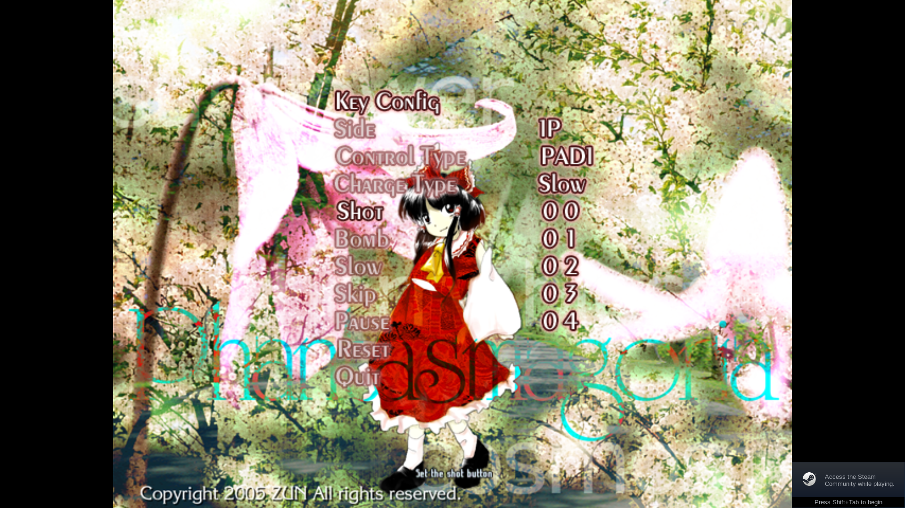
This menu should be repurposed to allow controls to be re-chosen at will by pressing the “select” key on a given key choice and then entering another key.
The game should store its keyboard layout as a binary file, with the below properties:
- The file format consists of a series of action-keycode pairs, meaning each keyboard-accesible action (e.g. shoot, move, take a screenshot) is assigned an ID (one byte) and is followed by a keycode which corresponds to the key that is assigned to that action.
- To designate the filetype, there is also a 4-byte “magic” string at the beginning of the file that reads “KCFG” in ASCII encoding.
- The default controls will be as laid out above.
Part II: Implementation guide
This second part will serve to more concretely specify how the game should work logically, such as providing the relationships between object-oriented structures, etc., and stating what properties and methods each object should have and in what manner they should be made available to each other.

0 General approach
A potentially apt way of separating concerns in the project is to separate the game into conceptual “scenes”, regions of gameplay with little or no overlap. These can be encapsulated entirely from the rest and have independent logic from all other scenes; however, via polymorphism, the game will only need to run the “update” method on the current scene in order to advance the game by one frame.

0.1 Window management
The game naturally requires a window in which to display, but this window may change size depending on the concrete display of the user; in fullscreen mode, the window needs to occupy the largest possible space on the screen, considering that the game is fundamentally based on a 4:3 aspect ratio. On other monitors, for instance, the full width (or indeed height) of the screen may not be able to be utilised with such an aspect ratio, so black bars must be drawn to the remainder of the screen and the main game content in the middle of the bars.
The game is natively 640x480 in resolution, unless in fullscreen, in which case it occupies as large a region of the screen as possible. In any non-native configuration, the screen is merely stretched to fit whatever proportions are desired.
Image below demonstrates how the window should behave if the screen has a wider aspect ratio than 4:3. If the screen were taller, the bars would be horizontal.
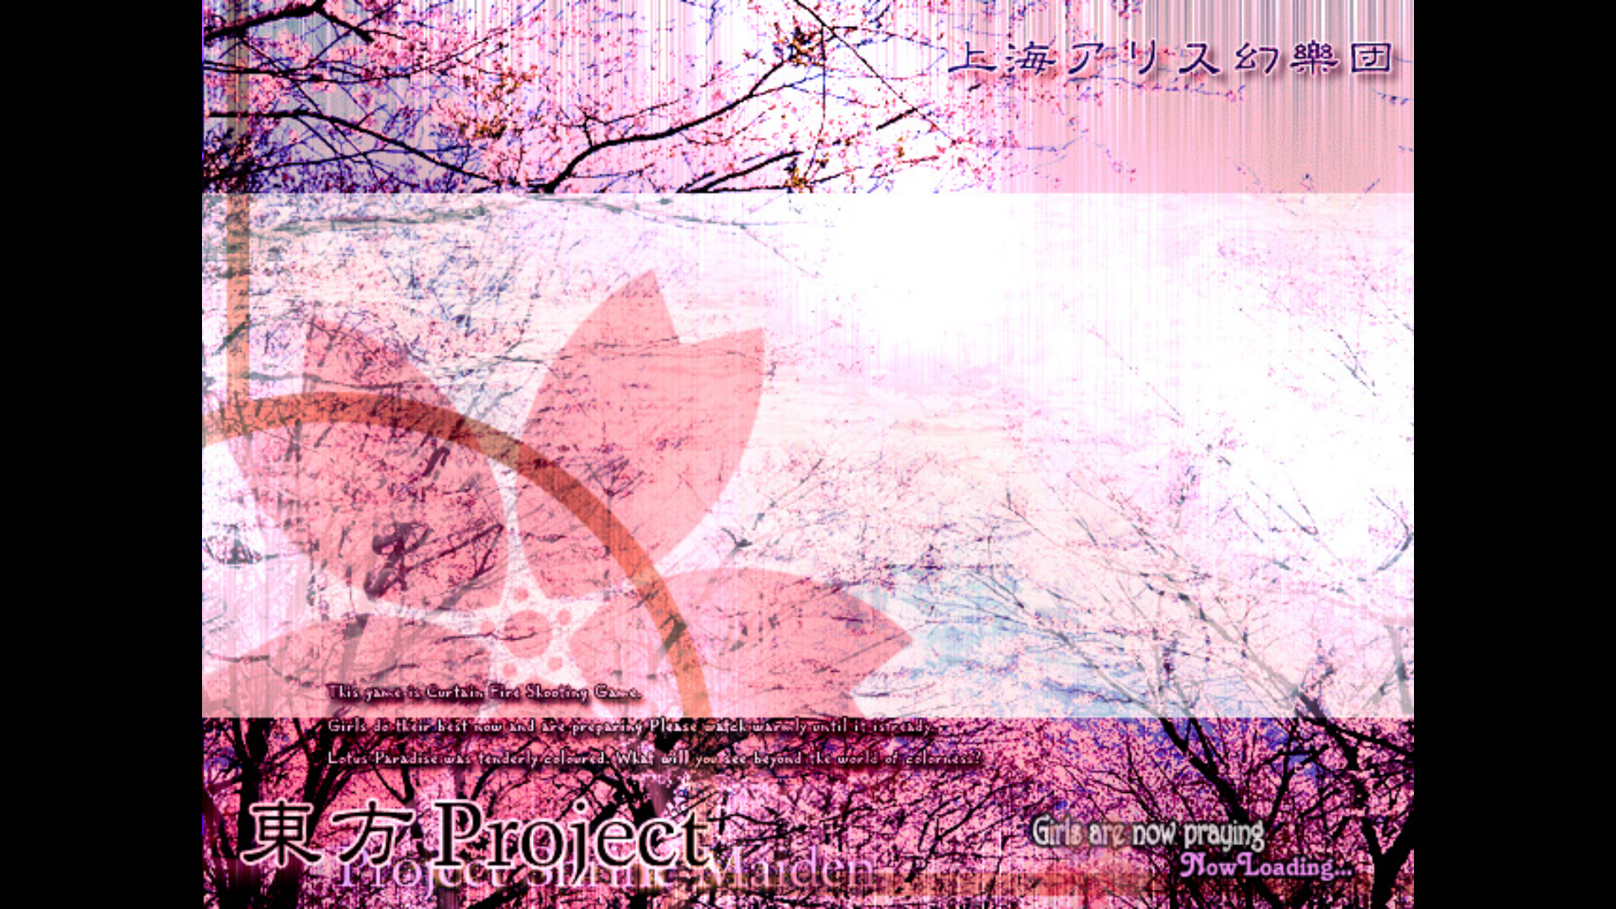

0.2 Scenes
A scene will be the vehicle of logic containment in the project. The scene can have as many of its own properties, methods, etc. as it would like, but must implement an update method with one argument, namely delta time, calculated in the main game loop.
There shall exist the following scenes:
- MainMenuScene
- GameplayScene
- CreditsScene
These regions of the game have nearly nothing in common, and don’t require communication between them to run independently. The main menu is simply a bootloader for the gameplay, which in turn facilitates playing the credits.

1 Main menu
Labels on the main menu should be implemented as objects, as below:
class MenuOption:
float base_x
float base_y
float x
float y
string tooltip
boolean available

